**CHAPTER ONE**

**INTRODUCTION**

**1.1 Background Information**

The use of energy from the sun is fast gaining acceptance in many countries of the world including Nigeria. The use of solar energy for drying is justified because of its inherent advantages compared to other techniques because the low capital and the running costs involved (Alonge and Oje, 2006). Sun drying is a traditional drying method generally used for reducing the moisture content of food materials, by spreading them under direct sunlight. Solar radiation from the sun heats up the grains as well as the surrounding air, leading to evaporation of water contained in the food stuff (Anonymous, 2021).

Sun drying is the most common drying method in Africa, due to its relative ease of use, and the low cost for adoption compared to other drying methods. It doesn’t have any negative effect on the environment, since it uses the sun as the heat source. Adity (2020) stated some demerits of Sun drying such as; It tends to be labor intensive, with limited capacity. Temperature cannot be easily controlled, and food materials can easily be overheated, causing cracking, and leading to wastage and inefficiency. Drying is only limited to clear sunny days, with rain, night and food materials are exposed to insects or animals (Anupam, 2016).

Solar drying on the other hand involves the use of specialized equipment called solar dryers to dry food materials. Solar dryers can be categorized into: Direct, indirect and mixed mode solar dryers, which are either Active or passive solar dryers. This work was carried out using the direct, active or forced convection solar drier. The direct solar dryer exposes the substance to be dehydrated to direct solar radiation (Wikipedia, 2021). In this system, the solar drying is assisted by the movement of the air that removes the more saturated air away from the items being dried on racks. The produce is contained in an enclosed space, and the air in contact with it is heated by solar radiation, this enclosure protects the food materials from the weather, animals and other contaminants (Belessiotis and Delyannis, 2011). In indirect solar dryers, the black surface heats incoming air rather than directly heating the substance to be dried. This heated air is then passed over the substance to be dried and exits upwards often through a chimney, taking moisture released from the substance with it (Wikipedia, 2021).

**1.2 Statement of the Problem**

Drying, an important unit operation in food engineering can be carried out in different methods. These methods vary in operation, cost and efficiency. The sun, a major source of free and easily available heat is often harnessed to facilitate drying, but the method in which this is done produces different results (Anupam, 2016). This work seeks to compare two methods of drying (sun drying and solar drying) that make use of heat from the sun and determine which of the two methods is the most effective method for dying.

**1.3 Objective of the Study**

The aim of this research is to carry out sun and solar drying of vegetables (pepper and tomatoes), and to investigate the effect of the drying techniques of the nutritional quality of the product.

The specific objectives of this project work are:

1. To compare sun drying and solar drying of pepper (*Scotch Bonnet)* and tomatoes (*Roma Tomatoes)*.
2. To determine the effects of drying on the nutritional quality of dried pepper (*Scotch Bonnet)* and tomatoes (*Roma Tomatoes)*.

**1.4 Significance of the Study**

This research work would give the best method of drying vegetables, thus improving drying efficiency in the food industry.

**1.5 Scope and Limitation of the Study**

The scope of this study centered on adopting and comparing sun and solar drying methods, in the drying of Scotch Bonnet pepper (*Capsicum chinense)* and Roma tomatoes (*Solanum lycopersicum)*, to get the most efficient method to be adopted for drying tomatoes, peppers and other vegetable, it also looked into the effect of the drying method on nutrient quality of the dried food.

**CHAPTER TWO**

**LITERATURE REVIEW**

**2.1 Tomato**

The tomato is the edible berry of the tomato plant (*Solanum lycopersicum)*, which originates from south America. Despite botanically being a fruit, it’s generally eaten and prepared like a vegetable (Wikipedia, 2021). Usually red when mature, tomatoes can also come in a variety of colors, including yellow, orange, green, and purple. What’s more, many subspecies of tomatoes exist with different shapes and flavor. Tomatoes are the major dietary source of the antioxidant lycopene, which has been linked to many health benefits, including reduced risk of heart disease and cancer. They are also a great source of vitamin C, potassium, folate, and vitamin K (Healthline, 2021).

**2.1.1 Plum tomatoes**

Plum tomatoes, also known as processing or paste tomatoes, plum tomatoes have an almost cylindrical shape and few seeds, making them perfect for preserving. As a result, they’re popular tomato paste, or diced and canned (Roma tomatoes are a plum variety). Smaller plum tomatoes are often called grape tomatoes **(**Sarra, 2019).

**2.1.2 Health Benefits of Tomatoes**

Tomatoes are an excellent source of vitamin C and other antioxidants. With these components, tomatoes can help combat the formation of free radicals. Free radicals are known to cause cancer (Megan, 2017). Xiaoming *et al*. (2016) stated that tomatoes contain lycopene, which is a polyphenol or plant compound, that has been linked with one type of prostate cancer prevention. It also gives tomatoes their characteristic red color.

The fiber, potassium, vitamin C, and choline content in tomatoes all support heart health. An increase in potassium intake, along with a decrease in sodium intake, is the most important dietary change the average person can make to reduce their risk of cardiovascular disease (Xiaoming *et al*., 2016) Tomatoes also contain folate. This helps to balance homocysteine levels. Homocysteine is an amino acid that results from protein breakdown. It is said to increase the risk of heart attacks and strokes. The management of homocysteine levels by folate reduces one of the risk factors for heart disease (Megan, 2017). Studies have shown that people with type 1 diabetes who consume high-fiber diets have lower blood glucose levels, while people with type 2 diabetes may have improved blood sugar, lipids, and insulin levels. One cup of cherry tomatoes provides about 2 grams (g) of fiber (USDA, 2020).

Eating foods that are high in water content and fiber, such as tomatoes, may help hydration and support normal bowel movements. Tomatoes are often described as a laxative fruit. Fiber adds bulk to stool and is helpful for reducing constipation. However, removing fiber from the diet has also demonstrated a positive impact on constipation (Megan, 2017).

According to the Age-Related Eye Disease Study (AREDS2, 2015), tomatoes are a rich source of lycopene, lutein, and beta-carotene. These are powerful antioxidants that have been shown to protect the eyes against light-induced damage, the development of cataracts, and age-related macular degeneration. A study by El-Sayed *et al*. (2013) found out that people with high dietary intake of the carotenoids lutein and zeaxanthin, both present in tomatoes, had a 35 percent reduction in the risk of neovascular diseases.

Collagen, essential component of the skin, hair, nails, and connective tissue. The production of collagen in the body is reliant on vitamin C. A deficiency of vitamin C can lead to scurvy. As vitamin C is a powerful antioxidant, a low intake is associated with increased damage from sunlight, pollution, and smoke. This can lead to wrinkles, sagging skin, blemishes, and other adverse health effects of the skin (Ruta, *et al*., 2012).

**2.1.3 Uses of Tomatoes**

Tomatoes withstand heating and cooking processes very well. As a result, it can be processed into a wide range of popular and convenient products, according to Waitross (2021), some products gotten from tomatoes are:

**2.1.3.1 Tomato Paste**

This coarse paste made from sun-dried tomatoes has a texture mid-way between sun-dried tomatoes in oil and tomato purée. Tomato paste is sold in jars and also contains sunflower and olive oils.

**2.1.3.2 Tomato Sauce**

Often confused with the condiment tomato ketchup, tomato sauce is a ready-made sauce made with chopped tomatoes. A variety of sauces are available, containing a range of different ingredients including onions, garlic, herbs, olive oil, chilies and mushrooms. It is sold in jars and also as a fresh sauce, fresh organic tomato sauce is also available.

**2.1.3.3 Tomato Juice**

A smooth, liquid form of tomatoes available in cans or bottles, mainly used as a drink, they can also be included in small quantities in recipes where a subtle tomato flavor and smooth texture are required.

**2.1.3.4 Tomato Ketchup**

One of the most popular condiments available, tomato ketchup can be found on café and restaurant tables all over the world. It is made from a combination of tomatoes, vinegar, sugar and spices and is available in glass or plastic bottles.

**2.1.4 Tomato Storage**

Tomatoes are best stored unwashed at [room temperature](https://en.wikipedia.org/wiki/Room_temperature) and out of direct sunlight. It is not recommended to refrigerate them as this can harm the flavor. Tomatoes stored cold tend to lose their flavor permanently (Joanna, 2016). Storing stem down can prolong shelf life, as it may keep from rotting too quickly. Tomatoes that are not yet ripe can be kept in a paper bag till ripening (Megan, 2017). They are easy to preserve whole, in pieces, as [tomato sauce](https://en.wikipedia.org/wiki/Tomato_sauce) or [paste](https://en.wikipedia.org/wiki/Tomato_paste) by home [canning](https://en.wikipedia.org/wiki/Canning). Tomatoes are one of the few fruits that can be canned really successfully, Plum tomatoes are normally selected for canning. Canned tomatoes are excellent in sauces for pastas and stews having an intense and distinct flavor (Waitross, 2021).

Tomatoes can also be preserved by drying, often in the sun, and sold either in bags or in jars with oil. These tomatoes can be pre-treated with sulfur dioxide or salt before being placed in the sun in order to improve color and appearance. Typically, tomatoes spend 4–10 days in the sun in order for the sun-drying process to be complete. Cherry tomatoes will lose 88% of their initial (fresh) weight, while larger tomatoes can lose up to 93% during the process. As a result, it takes anywhere from 8 to 14 kilograms of fresh tomatoes to make a single kilogram of sun-dried tomatoes (Wikipedia, 2021). Sun dried tomato fruits usually retain their nutritional value. The tomatoes are high in lycopene, antioxidants, and vitamin C. Sun-dried tomatoes can be used in a wide variety of recipes and come in a variety of shapes and colors, depending on the variety dried. Sun-dried tomatoes can also be available in the form of pastes or purées (Waitross, 2021).

**2.2 Pepper**

Pepper, often described as the "king of spices," is one of the world’s most important spices, it comes from the fruit (peppercorns) of a flowering shrub, in the genus *Piper,* family *Piperceaea*. (Makayla, 2019). The pepper plant originates from India, which is still the world’s largest producer of pepper. The plant grows in hot, humid regions such as India, Indonesia, Malaysia, and other parts of the world. Peppers are rich in vitamin C, A, E, Most B vitamins and in particular vitamin B5. They also are very high in potassium, magnesium, iron and rich in calcium and phosphorus (Wikipedia, 2021).

**2.2.1 Scotch Bonnet**

Scotch bonnet pepper (*Capsicum Chinense*), also known as bonney peppers, or Caribbean red peppers, is a variety of chili pepper named for its resemblance to a “tam o' shanter” hat It is ubiquitous in West Africa. the Scotch bonnet is brightly colored hot chile that is typically red or yellow when fully ripe (Kate, 2019). These peppers are used to flavor many different dishes and cuisines worldwide and are often used in hot sauces and condiments. Scotch bonnets are mostly used in West African cuisines and pepper sauces.

**2.2.2 Storage of Pepper**

Most fresh peppers can be left out for days, though some unripe peppers, like green bells, will lose moisture more quickly and are usually refrigerated after a day. (peppers store the best at between 45°F and 55°F). You can also freeze almost any kind of pepper for as long as a year (Kristen, 2009). in most parts on of the world and in Nigeria, peppers are dried to extend their shelf life.

**2.3 Drying**

Food drying is a very simple, ancient skill. It requires a safe place to spread the food where dry air in large quantities can pass over and beside thin pieces (Yasir and Muhammed, 2017). Sun is often used to provide the hot dry air. dry, clean air including dry cold air from any source will dehydrate food. Drying is an excellent way to preserve food, and solar food dryers are an appropriate food preservation technology for a sustainable world (Balogun *et al*., 2017).

The drying process involves complex heat and mass transfer phenomena, consisting of the removal of water or another solvent by evaporation from a solid, semi-solid or liquid. This process is often used as a final production step before selling or packaging products (Wikipedia, 2021).

Although the primary objective of drying is preservation, quality aspects are taken into account. It has been recognized that the important factor is not the water content but water availability for spoilage reactions. Microbial growth, either of natural or inoculated populations, causes chemical and textural changes to form a product that can be stored for extended periods (Balogun *et al*., 2017). Therefore, the main feature of this process consists on lowering the water content in order to avoid or slow down spoilage by microorganism. It is proven that in many agricultural countries, large quantities of food products are dried to improve shelf life, reduce packaging costs, lower weights, enhance appearance, retain original flavor and maintain nutritional value. (Kent *et al*., 2018)

**2.3.1 Mechanism of Drying**

Drying involves the vaporization and removal of water or other liquids from a solution, suspension, or other solid-liquid mixture to form a dry solid. It is an intricate process involving heat and mass transfer with other physiochemical transformations. Heat is usually supplied to heat-up feedstock, granules, food materials and so on. Upon the mechanism of heat transfer being talked about drying is categorized into direct (convection), indirect or contact (conduction), radiant (radiation), and dielectric or microwave (radio frequency) drying. (Parikh, 2014)

The mechanism of heat and mass transfer are very critical in the process of drying. When heat is applied to a product to cause evaporation, mass is transferred in form of vapor into the surroundings. Some useful variables being considered during drying are moisture content, drying rate and drying time. (Parikh, 2014)

**2.3.1.1 Drying Curves of Agricultural Products**

Drying behavior of solids can be described by measuring the function of moisture content loss versus time. Continuous weighing, humidity difference and intermittent weighing are the often used methods When drying crops using heated air, two drying periods generally occur viz: constant-rate period and falling rate period. Constant rate drying occurs with evaporation of surface water, while in falling rate period moisture movement is controlled by internal resistances (Chinweuba *et. Al.,*2016).

**2.3.1.2 Drying Rate Periods**

Drying curves characteristically display four defined regions or periods. Not every product will display all four, sometimes only one will appear and although the definition of each period is clear it may be difficult to ascertain in practice. Many agricultural products do not display typical drying curves, notably a lack of constant drying time. (Daniel *et. Al.,*2016).

**2.3.1.3 Initial Drying Period**

There is often an initial drying rate where the drying rate increases as the surface of the product is heated to the temperature of the immediate ambient air. A sufficient temperature gradient is required between the air and the product’s initial temperature to vaporize the moisture. (Daniel *et. Al.,*2016).

**2.3.1.4 Constant Rate Period**

This is the period After the initial period, this curve displays a constant drying rate through a limited time. During this time the surface of the product still contains free moisture, which is vaporized, diffused into the air and taken away by the air (Chinweuba *et. Al.,*2016). The rate is controlled by the diffusion process for water removed from the surface and into the air. Critical moisture content (MCcr) is defined as the moisture content at the end in the very last instant of the constant rate period. (Daniel *et. Al.,*2016).

**2.3.1.5 First Falling Drying Rate Period**

described as the time from the critical moisture content until the equilibrium moisture content. Equilibrium moisture content is the point at which the moisture vapour pressure in the solid is equal to the partial pressure of the vapour in the air (Chinweuba *et. al.,*2016).

**2.3.1.6 Second Falling Drying Rate Period**

The second falling rate commences when the drying process is controlled by the rate at which moisture can move through the solid. (Menon and Mujubar, 1987)

**2.3.1.7 Thin-layer drying**

This is a widely used method for determining the drying kinetics of fruits and vegetables (Alves-Filho *et. Al.,* 1997). The thickness of the layer is uniform and does not exceed 3 layers of particles. Temperature distribution of a thin-layer material is uniform. This is due to the thin-layer characteristics (Daniel *et. Al, .*2016).

**2.3.2 Importance of Drying**

The main goal of drying is to reduce moisture content to levels that halt or slow down the growth of spoilage microorganisms and incident of chemical reactions (Fellows, 2009). Drying is one of the most common processes used to improve food stability, since it considerably decreases the water activity of the material, reducing microbial activity and minimizes physical and chemical changes during its storage. Dried foods also, weigh less, have enhanced aesthetic and sensory effects (Kent *et al*., 2018)

**2.3.3 Equilibrium Moisture Content**

Equilibrium moisture content can be attained when porous food materials come in contact with moist air, and adsorb or desorb water molecules. This equilibrium moisture content mostly depends on the partial pressure of the water vapor in the surrounding air, and slightly on the air temperature commonly experienced in drying and storing foods. When the moisture content of food materials does not change with time for a given water vapor pressure and air temperature, it is then said to have attained the equilibrium moisture content. When the saturated vapor pressure at that temperature or air is reached, the equilibrium moisture content of food materials increases at a rapid rate. The end point of any adsorption or desorption process when left undisturbed is the attainment of equilibrium moisture content. (Chinweuba *et. Al.,*2016).

**2.3.3 Sun Drying**

Sun drying basically involves complete reliance on the power of the sun, with the help of natural airflow. It is a gentle process involving a simple reaction of the sun's heat with your food. Since the sun drying method involves being slow and steady, the interesting and unique flavors that it imparts to the sun-dried food can be vastly different from that of fresh food (Adity, 2020). This is the reason why sun drying is a popular method of cooking even in highly modernized kitchens of the global world we live in today. drying is also a relatively low cost, low-investment and environment-friendly method of preserving food (Digvir, 2016).

There are also a few disadvantages of preserving food through the process of sun drying as well. Firstly, temperature cannot be controlled and food may tend to get overheated at times. sun drying is also labor-intensive and is slightly risky as it involves heavy reliance on unpredictable weather conditions (Adity, 2020).

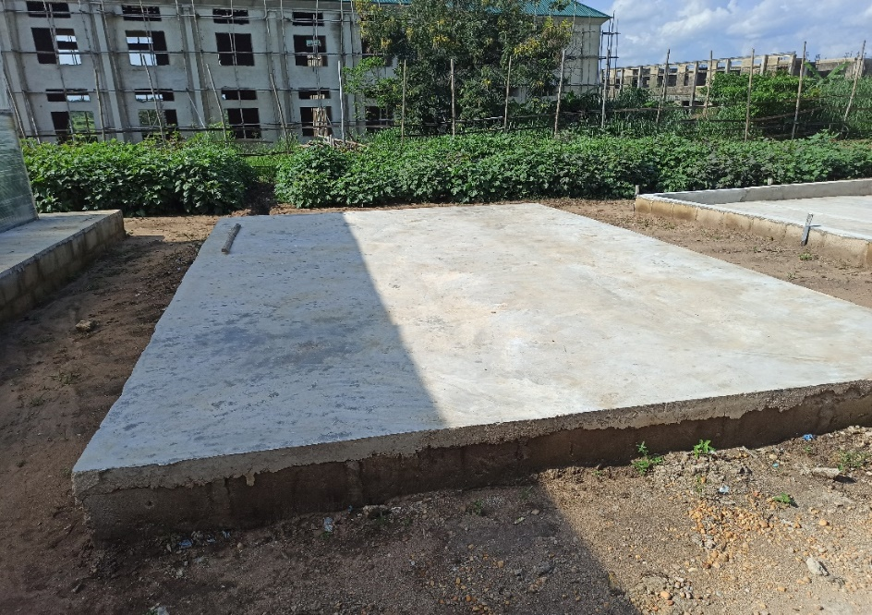

**Figure 2.1: Sun drying slab**

**Source: TETFUND NRF Zobo Project (2020)**

**2.3.4 Solar Drying**

This involves the usage of specialized equipment (solar dryers) that use solar energy to dry substances, especially food. There are three general types of solar dryers: Direct, indirect and combined dryers.

**2.3.4.1 Types of Solar Dryers**

**2.3.4.1.1 Direct Solar Dryers**

In the direct solar dryer, the samples to be dehydrated are exposed to direct sunlight, with the drying process being improved by the movement of the air (wind) that removes the more saturated air away from the items being dried (Wikipedia, 2021).

**2.3.4.1.2 Indirect Solar Dryers**

In indirect solar dryers, black surface heats incoming air rather than directly heating the substance to be dried. This heated air is then passed over the substance to be dried and exits upwards often through a chimney, taking moisture released from the substance with it (Wikipedia, 2021). One of the advantages of the indirect system is that it is easier to protect the food, or other substance, from contamination whether wind-blown or by birds, insects, or animals. Also, direct sun can chemically alter some foods making them less appetizing (Energypedia, 2020).

**2.3.4.1.3 Combined Dryers**.

Combined solar dryers’ dry combine the working principle of the direct and the in direct solar dryers. products are dried by direct radiation and heated moving air (Gupta and Sootha, 2015). Solar dryers can also be classified into:

**2.3.4.2 Forced Convection/ Active Solar Dryer**

It is a permanent and large scale use of the solar dryer, Here, the solar heat absorbing panel utilizes the whole roof area and constitutes the roof top of the drying chamber. Air circulation is done by means of an electrically drying fan. Ambient air is drawn in from one end of the solar inlet, heated by solar energy as it passes along the length of the absorber, and then hot air is discharged into the drying chamber. The material to be dried could be placed on trays or in bins with a perforated bottom (Gupta and Sootha, 2011).



**Figure 2.2: A forced convective/ active solar dryer**

**Source: TETFUND NRF Zobo Project (2020)**

**2.3.4.3 Passive Solar Dryer**

In a passive solar dryer, air is heated and circulated naturally by buoyancy force or as a result of wind pressure or in combination of both. Normal and reverse absorber cabinet dryer and greenhouse dryer operates in passive mode. Passive drying of crops is still in common practice in many Mediterranean, tropical and subtropical regions especially in Africa and Asia or in small agricultural communities (Balasuadhakar *et.al.,* 2016)

**2.3.5 Determination of Moisture Content**

The average moisture content of the sample was determined based on wet bases (w.b) according to the AOAC method. Three empty crucibles were dried in the oven and weighed. About 5g of the sample was added to the crucible and weighed. The crucible with sample was placed in the oven and dried for 3h at 105 $℃$. After drying the crucible is transferred to a desiccator to cool. The crucible is reweighed with the dried samples (AOAC, 2010). Moisture content was calculated using the following equation:

$M = \frac{{(W}_{o} -W) - W_{I}}{W_{I}}$ (2. 1)

Where 𝑀 is the moisture content (kg water/kg dry matter), $W_{o}$ is initial weight of sample (kg), 𝑊 is the amount of evaporated moisture (kg), and $W_{I}$ is dry matter content of sample (kg).

**2.3.6 Amount of Moisture to be Removed from the Product**

The amount of moisture to be removed from a sample of wet tomatoes, in order to bring the moisture content to safe moisture content for storage at a specific time was estimated using:

Ww = Wg (Mi-Mf) / (100-Mf) (2.2)

Where:

Ww = amount of moisture to be removed (kg)

Wg = initial mass of wet crop to be dried; (2 kg) potato

Mi = initial moisture content, w.b. of tomato = 93%

Mf = the desired final moisture content, d.b. of tomatoes sample = 12%

**2.3.7 Average Drying Rate**

The average drying rate is determined from the mass of moisture to be removed by solar heat and drying time by the following equation:

Wdr = Ww / td (2.3)

Where: Wd = avearage drying rate (hg/hr)

Ww = amount of water moisture to be removed

td = total drying time

**CHAPHTER THREE**

**MATERIALS AND METHODS**

**3.1 Sample Collection**

Fresh ripe Scotch Bonnet pepper (*Capsicum chinense)* and Roma tomatoes (*Solanum lycopersicum)*, were procured from Akpan Andem market in uyo akwa Ibom state, Nigeria. A specific quantity of fresh tomatoes and peppers were carefully sorted out and purchased from a vegetable vendor in the market (Figure 3.1). The samples were collected in polypropylene bags and taken to Botany department for identification, and then later taken to the food engineering laboratory University of Uyo, for drying and for experimental analysis. The peppers and tomatoes were sorted and cleaned by washing in running tap water, left to dry, and then weighed.

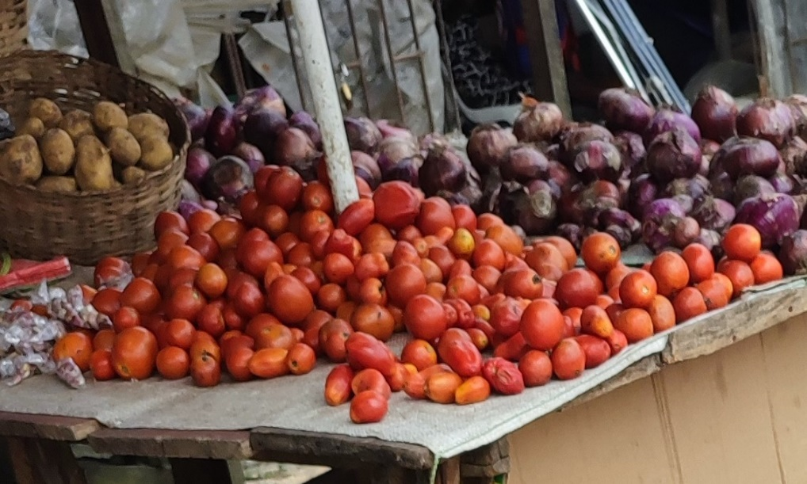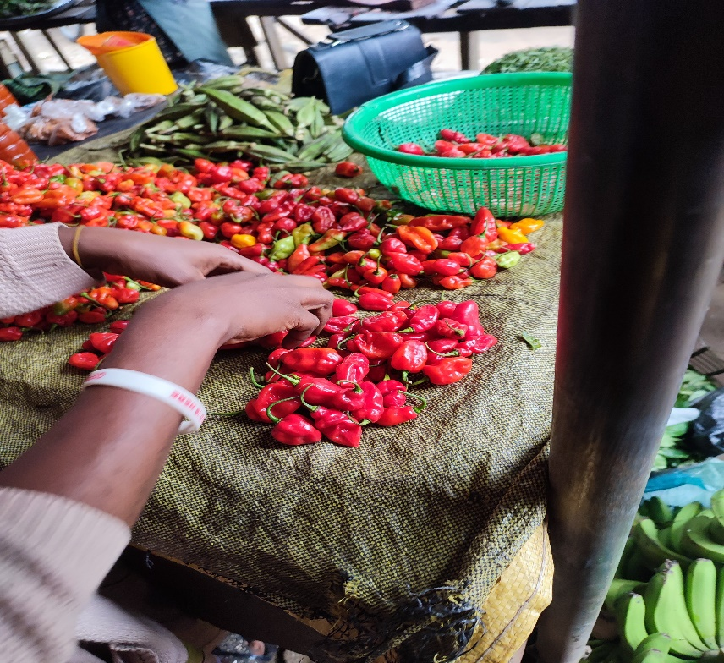

**Figure 3.1 Selection of samples.**

**Source: Udoh (2021).**

**3.2 Materials and Equipment**

The equipment and instrument used in this research are as follows; Glass dishes, desiccator, crucibles, electric shaker, beakers, filter paper, oven, desiccator, furnace, volumetric flask, test tubes, measuring cylinder, pipette, burette, separating funnel, soxhlet extractor, digital weighing balance, cooking pots, gas cylinder, fume cupboard, kjeldahl apparatus, soxhlet apparatus, muffle furnace, bottles and conical flask. Chemicals used were Sulphuric acid, sodium sulphate anhydrous, double indicator, distilled water, boric acid, hydrogen chloride, n-Hexane and sodium hydroxide.

**FIGURE 3.1: Flow process diagram for sun and solar drying of pepper and tomato.**

**3.3 Sample Preparation**

After the collection of Pepper and tomato samples, they were properly cleaned to removed dirt, after which the pepper and tomato samples were both divided into three separate sets, the first set was solar dried, the second set was sun dried, while proximate analysis and vitamin test was carried out on the last set (fresh sample) and used as control. The first two sets of pepper and tomato Samples where then sliced into thin layers (3mm) to help improve drying efficiency (Figure 3.2 below) and weighed with the various weights recorded.

Weighed samples were then spread out on drying trays, with enough space between them, the drying trays were then placed carefully into the solar dryer and the other on the sun drying pavements. Weight of the samples were recorded at 30 minutes’ interval until a constant weight was obtained, temperature was also recorded automatically with a temperature data logger.

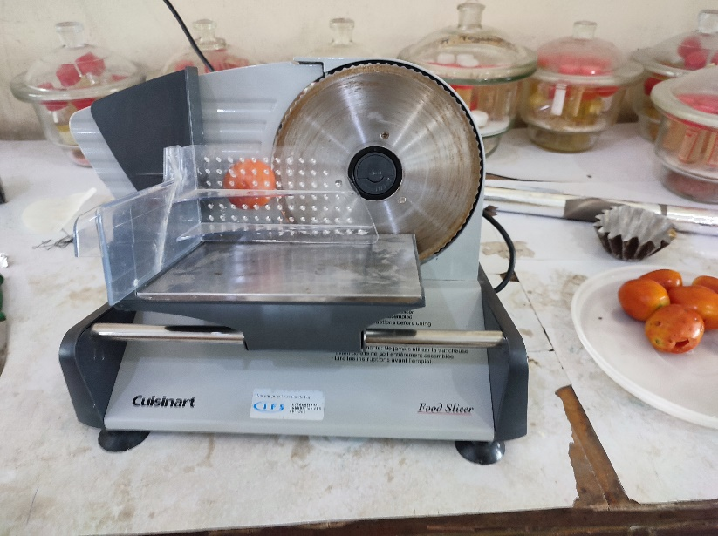 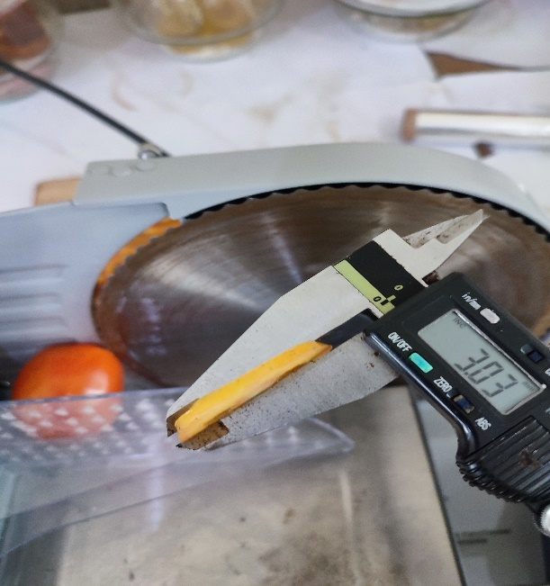

**Figure 3.2: Slicing machine (left), thin layer (3mm) slicing of samples**

**Source: Udoh (2021).**

**3.3.2 Dry Characteristic**

Drying kinetics is generally evaluated experimentally by measuring the weight of a drying sample as a function of time. Drying curves may be represented in different ways; averaged moisture content versus time, drying rate versus time, or drying rate versus averaged moisture content (Kett, 2019).

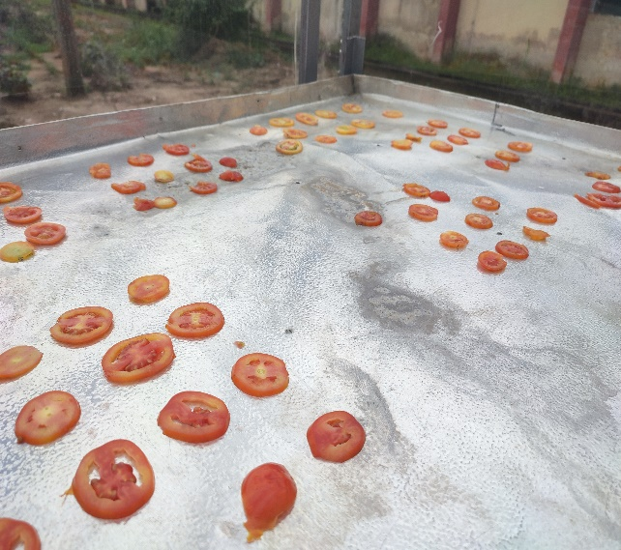 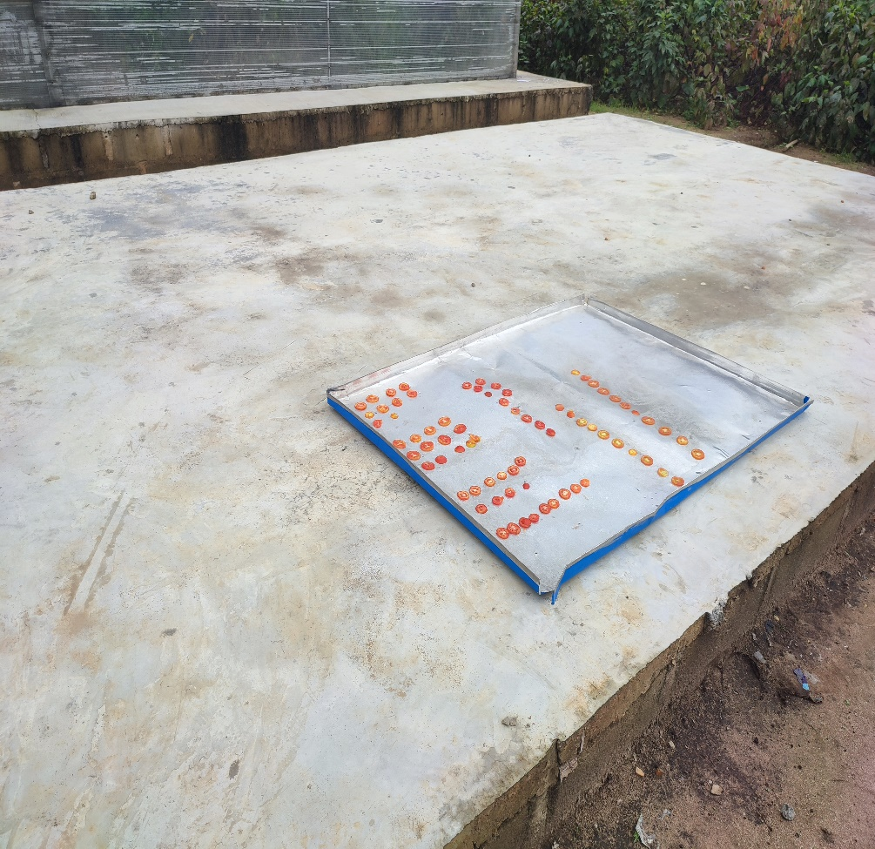

**Figure 3.2 Spaced out arrangement of solar (left) and sum dried (right) tomatoes**

**Source: Udoh (2021).**

**3.4 Chemical Composition**

Factors determined in the experiments were: moisture content, Vitamin C and A determination, ash content and crude fiber content was determined According to the standard methods of Analysis of Association of Official Chemists (AOAC, 2010), the methods are described below. The same procedures were carried out on all samples.

**3.5 Proximate Analysis of the Samples**

The chemical composition of the pepper and tomatoes sample was determined using the standard methods of analysis of Association of Official Analytical Chemists (AOAC 2010). Crude protein, ash, fat, fiber, crude protein, Moisture content, vitamin C and A contents in the samples were analyzed. The methods are described below. The same procedures were carried out on all sample, and every experiment was carried out in duplicate.

**3.5.1 Moisture Determination**

The moisture content was found according to AOAC (2010). Five grams (5g) of the ground sample was placed in a clean, dried pre-weighed crucible, the crucible containing the sample was then placed in an oven at 1050C, removed, allowed to cool in a desiccator and weighed at 30 minutes’ interval until uniform weight was recorded continuously. Weight loss was then recorded and the moisture content calculated using the equation.

$\% Moisture Content (db)=\frac{M_{i}-M_{f}}{M_{f}} ×100$ (3.1 a)

$\% Moisture Content (wb)=\frac{M_{i}-M_{f}}{M_{i}} ×100$ (3.1 b)

Mi is the initial mass of the sample (g)

M2 is the final mass of the sample (g).

**3.5.2 Fat Extraction**

The fat content was determined using method described by Okafor et Al (2018). Fat analysis was performed using sohxlet extraction apparatus. The apparatus consists of an extraction unit and a control unit. Approximately 3g of the sample (300mic, 212mic and base) was weighed, wrapped in a filter paper, and placed in a thimble and extracted with n-hexane for five hours. The thimble was placed on an electric heating Mantle to heat the sample with extraction solvent. The 4-step extraction procedure consisting of boiling, rinsing, recovery and pre-drying was observed. Empty beakers were cleaned, dried in an oven, and cooled in the desiccator before weighing (W1). After extraction, the solvent remnant was poured into the beaker and weighed as (W2). The beaker was placed in water bath for the solvent to evaporate from the fat residue. The beaker and contents were cooled in a desiccator and weighed (W3). The fat content was divided by the original sample weight and expressed in percent.

The fat content was calculated using.

% Fat $=\frac{W_{3-W_{1}}}{W_{2-W_{1}}}× 100$ (3.2)

**3.5.3 Determination of Crude Fibre**

Two (2.00g) of sample was defatted in 200ml of N-hexane for 2 hours in a 250ml conical flask; after this 200ml of 5M sulphuric acid was added to the flask and the mixture was boiled under reflux for 30 minutes. The hot solution was quickly filtered with Buckner funnel equipped with muslin cloth. The residue was washed thrice with hot water, scooped into a round bottom flask and digested with 200ml of 1.28% NaOH solution under reflux for 30 minutes boiling. 1% of HCL solution was them poured into the filtered digest. The digest was cooled, filtered and washed thrice with distilled water. The residue obtained was then drained and scooped into a weighed dry crucible and put into an oven to dry at 105°C to a constant mass. The crucible and dried sample was then reweighed and then placed in the muffler furnace to Ash at a temperature of 550°C for 3hours. Ashed sample was the removed from the furnace and cooled in a desiccator, the weighed. The difference in mass of the sample was calculated as crude fiber and expressed as a percent of the initial mass (A.O.A.C., 2010).

The crude fiber was then calculated using the formula

Crude fibre content (%) = $100x\frac{(B-A)}{C}$ (3.3)

Where A = weight of the crucible with dry residue (g)

B = weight of crucible with ash (g)

C = weight of sample (g)

**3.5.4 Determination of Total Ash**

A crucible, which had been dried for at least 2 hours at 100°C from oven to desiccator, cooled and its weight was recorded (W1), 5 g of sample was weighed into the crucible (W2). The samples were ashed in furnace at 600°C for 2 hours. Crucible was removed from furnace after it has completely turned white and allowed to cool in a desiccator and weighed, W3 (AOAC, 2010).

Ash (%) = $\frac{W_{3-W_{1}}}{W_{2-W_{1}}}×X100$ (3.4)

**3.5.5 Protein Determination**

The kjeldahl apparatus was used for the determination of crude protein. Protein determination was carried out in three stages, as follows:

**3.5.5.1 Digestion**

Approximately 0.15g of the sample (300mic, 212mic and base) was weighed and placed into a kjeldahl digestion flask followed by the addition of 1.5 g of copper (11) sulphate, 1.5g of sodium sulphate anhydrous and 10ml of suphric acid. The mixture was heated until it became colorless, and was allowed to cool. The sample was diluted to a 100 ml volume of distilled water and 40 percent concentrated NaOH was added and then mixed thoroughly. The mixture was then allowed to cool before distillation.

**3.5.5.2 Distillation**

50ml of conical flask was washed, dried in the oven and then cooled in a desiccator.25ml of 2 percent concentrated of boric acid was weighed into the conical flask and 2 drops of mixed indicator methyl red and blue was introduced. The mixture was distilled and the ammonia was entrapped in a receiving solution containing boric acid with purple indicator. The distillation lasted for 20 minutes and the boric acid color turned to green.

**3.5.5.3 Titration**

A total of 50ml of the distillate were collected and titrated with 0.1M HCl acid. The titre value of the HCL was obtained when the color of the digest change the difference obtained used to calculate the crude protein the percent nitrogen content was calculate using (addy and eteshola, 1984).

$\% Nitrogen content=\frac{0.14 * titre (sample)}{weight of sample}$ (3.5)

$\% Protein=\% Nitrogen x 6.2$ 5

**3.5.6 Determination of Vitamin C**

One gram (1g) of the sample was extracted with 10ml of TCA 6g/100ml. filter and pipette 1ml of the clear solution into a test tube. The standards were pipetted into a test tube (1ml). 1ml of the 6g/100ml TCA was pipetted into a test tube as a blank. 1ml of DTCS reagent was added to all the tubes, which were caped, mixed and incubated in a water bath at 37°C for 3hrs.The tubes were removed from the water bath and chilled for 10min in an ice bath while mixing slowly. 2ml of cold 12M sulphuric acid was added to the tubes. The spectrophotometer was adjusted with the blank to read zero absorbance at 520nm and then the absorbance of standard and test read. The result can be extrapolated from the standard plot or calculated as;

$\frac{Abs test ×conc std}{Abs test ×wt of sample} ×100$ (3.7)

**3.5.7 Carotenoid Analysis**

The carotenoid extraction was carried out based on done based on the procedure described by (Rodriguez Amaya and D Kimura 2004). Homogenization of 3 g of sample was done using mortar and pestle with successive addition of 25 ml of cold acetone order to extract the carotenoid. The mixture was suctioned and filtered through sintered funnel coupled with bucker flask under vacuum repeatedly until sample became colorless. The extract was transferred to a 500 ml separatory funnel containing 40 ml of petroleum ether. The acetone was washed by slowly adding ultra-pure water along the wall of the separatory funnel to prevent emulsion The lower aqueous phase was discarded this method was repeated until there is no residual solvent remaining The extract was then transferred to a 50 ml volumetric flask containing 15 g of sodium sulphate anhydrous in order to remove residue water The volume was made up with petroleum ether and the absorbance read at 450 nm using a spectrophotometer.

Carotenoid content was calculated using:

$\frac{T.c.t. ug}{g}=\frac{a*v(ml*{10}^{4})}{A^{1\%}1cm*p(g)}$ Eq. 10

Where A = Absorbance

V=volume of extract (ml)

$A^{1\%}1cm*p(g)$ =2592(B-carotene absorption coefficient in petroleum ether)

p= Weight of sample (g)

**3.5.8 Statistical Analysis**

Non-linear regression analysis and analysis of variance (ANOVA) at 5% significance level, and comparison of means by Duncan's multiple range test were done by statistical software, SPSS version 16 (SPSS Inc., Chicago, Ill., U.S.A. and the graphing was done by Origin pro version 9.2.214 (OriginLab Corporation, Northampton, MA, USA)

**CHAPTER FOUR**

**RESULTS AND DISCUSSION**

**4.1 Results**

The results of the study are presented this chapter. They are also discussed alongside.

**4.1.1 Temperature Variation with Drying Time**

The plots of temperature variation with drying time for drying tomato and pepper are shown in Figure 4.1 and 4.2.

**Figure 4.1: Plot of temperature variation with drying time for drying tomato.**

**Figure 4.1: Plot of temperature variation with drying time for drying pepper.**

From Figure 4.1, sun drying of tomato recorded the temperature fluctuation between 27.6 – 32.00C with the mean value of 29.9 ±1.20C, while solar drying of tomato had higher temperature fluctuation within 29.5 – 43.0, with an average value of 36.2± 1.20C. Similar trend was observed for pepper where open sun drying recorded mean temperature of 29.8 ±1.10C with fluctuation from 27.6 to 32.00C while solar drying of pepper had temperature range of 29.5 – 40.50C with mean value of 35.4 ± 3.70C. This could be evident in the shorter drying time solar system used to completely remove greater amount of water from the product.

**4.1.2 Moisture Content Variation with Drying Time**

The plots of moisture content variation with drying time for both tomato and pepper dried in open sun and solar dryer are shown in Figures 4.1 and 4.2.

**Figure 4.1: Plots of moisture content versus drying time for tomato dried in open sun**

**and solar dryer**

**Figure 4.2: Plots of moisture content versus drying time for pepper dried in open sun**

**and solar dryer**

From Figures 4.1 and 4.2, generally, the moisture content (MC) decreased with increase in drying time for both tomato and pepper. The average initial MC of tomato was 94.3% wb for both open sun and solar dryer while that of pepper in the open sun and solar dryer were 85.6 and 81.1%wb respectively. Tomato had more moisture content than pepper as it should be expected. However, solar dryer took shorter time frame to complete the drying process than the open sun.

**4.1.3 Drying Rate**

The plots of drying rate versus drying time for both tomato and pepper dried in open sun and solar dryer are shown in Figures 4.3 and 4.4.

**Figure 4.3:** **Plots of drying rate ($\frac{dw}{dt}$) versus drying time for tomato dried in open sun**

**and solar dryer**

**Figure 4.4:** **Plots of drying rate ($\frac{dw}{dt}$) versus drying time for pepper dried in open sun**

**and solar dryer**

From Figures 4.3 and 4.4, there were rising, fairly constant and falling rate periods. Between 240 – 270 minutes, a maximum of 0.012 g H20 was removed /min in tomato dried in the open sun. Similar trend was observed when it was dried with solar dryer where maximum of 0.012 g H20 was removed /min within 240 to 330 minutes. The rates later decreased till 450 mins and 390 mins where 0.009 and 0.011 g H20 was removed /min for sun and solar dried tomato respectively. Between 240-300 min, and 300 mins, sun and solar dried pepper respectively recorded maximum of 0.0019 and 0.0022 g H20 removed /min. Their rates obviously decreased beyond these periods till 420 and 330 minutes where 0.0016 and 0.0018 g H20 were finally removed per min. The trends as observed follow general drying curve for all food and agricultural products.

**4.2** **Proximate Composition of Fresh and Dried Tomato and Pepper Samples**

The mean values of proximate composition comparing the fresh sample with the sun and solar dried samples of tomato and pepper using Dunnett’s t-test are presented in Tables 4.1 and 4.2.

**Table 4.1: Mean Values of Proximate Composition Comparing the Fresh Sample**

**with the Sun and Solar Dried Samples of Tomato using Dunnett’s T-test**

|  |  |  |  |  |  |  |
| --- | --- | --- | --- | --- | --- | --- |
|  | **MC% (w.b)** | **Protein %** | **Fat %** | **Fibre %** | **Ash %** | **CHO %** |
| SO | 9.510 ± 0.01a | 0.815 ± 0.12a | 0.23 ± 0.01a | 1.85 ± 0.14a | 4.29 ± 0.04a | 83.31 ± 0.04a |
| SU | 9.165 ± 1.08b | 1.101 ± 0.11a | 0.28 ± 0.10a | 1.43 ± 0.01b | 3.61 ± 0.10b | 85.34 ± 1.18b |
| FR | 95.087± 0.11c | 1.130 ± 0.01a | 0.32 ± 0.05a | 1.16 ± 0.08c | 2.13 ± 0.01c | 0.174 ± 0.11c |

X ± SD represents mean ± standard deviation. Mean values with same superscript are not significantly different from each other at 5% level of Probability using Dunnett’s T-test. SO= solar dried sample, SU = sun dried sample and

FR =fresh sample (control)

Deduction: Drying method had slight effect on protein and fat contents.

**Table 4.2: Mean Values of Proximate Composition Comparing the Fresh Sample**

**with the Sun and Solar Dried Samples of Pepper using Dunnett’s T-test**

|  |  |  |  |  |  |  |
| --- | --- | --- | --- | --- | --- | --- |
|  | **MC% (w.b)** | **Protein %** | **Fat %** | **Fibre %** | **Ash %** | **CHO %** |
| SO | 6.18 ± 0.88a | 1.10 ± 0.01a | 0.52 ± 0.07a | 1.09 ± 0.01a | 5.25 ± 0.07a | 85.68 ± 1.04a |
| SU | 4.79 ± 0.59b | 1.17 ± 0.01a | 0.50 ± 0.09a | 1.27 ± 0.01b | 4.42 ± 0.20b | 87.86 ± 0.73b |
| FR | 86.77± 0.61c | 1.31 ± 0.11a | 0.54 ± 0.05a | 0.68 ± 0.00c | 2.66 ± 0.01c | 8.042 ± 0.68c |

X ± SD represents mean ± standard deviation. Mean values with same superscript are not significantly different from each other at 5% level of Probability using Dunnett’s T-test. SO= solar dried sample, SU = sun dried sample and FR =fresh sample (control)

Deduction: Drying methods had slight effect on protein and fat contents

**4.3** **Carotenoid and Vitamins C Composition of Fresh and Dried Tomato and Pepper Samples**

The mean values of Carotenoid Vitamin C composition comparing the fresh sample with the sun and solar dried samples of tomato and pepper using Dunnett’s t-test are presented in Table 4.3.

**Table 4. 3: Summary of Comparison of Carotenoid and Vitamin C in the Fresh Sample**

**as Control with the Sun and Solar Dried Samples of Pepper Using Dunnett t-test**

|  |  |  |  |  |  |
| --- | --- | --- | --- | --- | --- |
|  | **Values of vitamins for Tomato**  **(mg/100g)** | |  | **Values of vitamins for Pepper**  **(mg/100g)** | |
| **Drying Methods** | **Carotenoid** | **Vitamin C** |  | **Carotenoid** | **Vitamin C** |
| SO | 30.028 ± 2.64c | 90.334± 0.05c |  | 92.078± 0.00c | 183.570± 0.02c |
| SU | 14.21± 1.09b | 33.745± 0.01b |  | 90.599± 0.18b | 124.005± 0.78b |
| FR | 63.344± 0.26a | 140.020± 0.06a |  | 126.672± 0.18a | 260.363± 0.07a |

X ± SD represents mean ± standard deviation. Mean values with same superscript are not significantly different from each other at 5% level of Probability using Dunnett’s T-test. SO= solar dried sample, SU = sun dried sample and FR =fresh sample (control)

Deduction: The amounts of Carotenoid and vitamin C in both fresh samples were significantly reduced when dried in the SO and SU. Vitamins are generally sensitive to heat. Hence, heat application destroys its component. Drying methods had affected vitamin contents.

**Figure 4.3:** **histograms showing carotenoid and vitamin C content variation for all sun**

**and solar drying methods compared with fresh samples.**

**CHAPTER FIVE**

**CONCLUSION AND RECOMMENDATION**

* 1. **CONCLUSION**

From the experiment, the average drying time recorded for sun drying tomatoes was 7 hours and 30 minutes (450 minutes) while solar drying of tomatoes took an average time of 6 hours and 30 minutes (390 minutes) with a maximum of 0.012 g H20 removed /min in tomato dried in the open sun. Similar trend was observed in the solar dryer where maximum of 0.012 g H20 was removed /min within 240 to 330 minutes. The rates later decreased till 450 mins and 390 mins where 0.009 and 0.011 g H20 was removed /min for sun and solar dried tomato respectively. Pepper was sun dried under 7 hours (420 minutes), and solar dried in 5 hours and 30 minutes (330 minutes). There was a recorded temperature fluctuation between 27.6 – 32.00C for sun drying with the mean value of 29.9 ±1.20C, while the solar dryer had higher temperature fluctuation within 29.5 – 43.0, with an average value of 36.2± 1.20C.The average initial MC of tomato was 94.3% wb for both open sun and solar dryer while that of pepper in the open sun and solar dryer were 85.6 and 81.1%wb respectively. Tomato had more moisture content than pepper as it should be expected. However, the solar dryer took shorter time frame to complete the drying process than the open sun.

It was noted that the placement of the sample to be dried relative to the inclination of the solar dryer roof differed, with samples closer to the roofing material drying faster than those further away from the material. As expected, the drying rate at different levels of the solar dryer also differed, with the lower levels drying faster than the upper levels.

The drying methods had noticeable effect on the protein and fat content of the food, with The amounts of Carotenoid and vitamin C in both fresh samples significantly reduced when sun dried. There was a noticeable decrease in the carotenoid and vitamin C content of solar dried tomato, but it should be noted that the decrease was lower than that observed in the sun dryer. Vitamins are generally sensitive to heat. Hence, heat application destroys its component. Drying methods had affected vitamin contents.

* 1. **RECOMMENDATIONS**

1. Further research should be carried out to ascertain the drying rate of vegetables at different levels of the solar dryer.
2. Further research should also be carry out to know the drying rate of vegetables at different placements relative to the inclination of the solar dryer roof.

**REFERENCE**

Addy E. and Eteshola E (1984) “Nutritive value of mixture of tigernut tubers (Cyperus

esculentus L.) and Baobab seeds (Adansonia digitate L.).” *journal of science and food*

volume 35 pages 437-440.

Adity ahuja (2020) “all about sub drying food: meaning, benefits and how it works”. Online

at:h[ttps://www.google.com/amp/s/food.ndtv.com/food-drinks/all-about-sun-dryingm](ttps://www.google.com/amp/s/food.ndtv.com/food-drinks/all-about-sun-drying-m)eaning-benefits-and-how-it-works-2239586%3famp=1&akamai-rum=off. [accessed on 9/4/2021]

Alonge, A.F. and Oje, K. (2006) “Determination of The Optimum Angle of Inclination of

Flat Plate Solar Collectors for Solar Dryers in Kwara State, Nigeria”, *journal of applied science, engineering and technology*, vol. 6, number 1:22-26

Alves-Filho O, Strommen I, and Thorbergsen E. (1997) “A simulation model for heat pump

dryer plants for fruits and roots. Drying Technol” chapter 15(5): pages 1369–1398

Anonymous (2021) “Sun Drying”. Online at: http://www.knowledgebank.irri.org/step

by-step-production/postharvest/drying/traditional-drying-systems/sun-drying [accessed on 9/4/2021]

Anupam Tiwari (2016) “A Review on Solar Drying of Agricultural Produce”, *journal of food*

*Processing technology* (2016), 7:9

AOAC. (2010) Official methods of analysis of aoac international Association of Official

Analysis Chemist Intenational. <http://doi.org/10.3109/15563657608988149>

AREDS2 (2015) Age-Related Eye Disease Study 2 “AREDS Report no. 8: A Randomized,

Placebo- Controlled, Clinical Trial of High- Dose Supplementation with Vitamin C and E, Beta Carotene, And Zinc for Age-Related Macular Degeneration and Viaion Loss”. Achieves of ophthalmology. 119. Pages 1417- 1422

ASAE (2000), American Society of Agricultural Engineers Standard Year Book, 345p.

Balogun, M.B., Anafi, F.O. and Kulla, D.M. (2017) “performance evaluation of a double

compartment solar dryer”. Nigerian Journal of Solar Energy, Vol. 28, 2017.

Belessiotis, v., Delyannis, e. (2011) “Solar Drying”. Solar Energy 85, pages 1667-1691.

Balasuadhakar, A., Amessalu, A., Bariso, B., Teklebirhan, F. (2016) “A Review on Passive

Solar Dryers for Agricultural Products”, IJIRST –*International Journal for Innovative Research in Science & Technology* Vol. 3, Issue 01, (2016) ISSN (online): 2349-6010

Chinwuemba D.C., Nnaemeka R.N., Okafor V.C. Charles N. (2016) “Thin Layer Drying

Modeling for Some Selected Nigerian Produce: A Review”, *American Journal of Food Science and Nutrition Research* 2016; 3(1) 1-15

Daniel I.O., Norhashila H., Rimfiel B.J., Nazmi M.N., Khalina A. (2016) “Modeling the Thin

Layer Drying of Fruits and Vegetables: A Review”, Comprehensive Reviews in Food Science and Food SafetyVol 15, Issue 3, P. 599-618

Digvir S. Jayas. (2016) “food dehydration”, Reference Module in Food Science, 2016

El-Sayed M. a., Humayoun A., and Rashida A (2013) “Dietary Sources of Lutein and

Zeaxanthin Carotenoids and their Role in Eye Health”. Online at: <https://www>

.nlm.nih.gov/pmc/articles/Pmc3705341/ [accessed on 15/4/2021]

Emily, Y. C. (2015). “Secondary Analyses of the Effects of Lutein/Zeaxanthin on Age-

Related Macular Degeneration Progression AREDS2 Report No.3”

Energypedia (2020) “Solar Drying”. Online at: https://energypedia.info/wiki/Solar_Drying

[accessed on 11/4/2021]

FAO (2002): Food and Agricultural Organization of United Nations. Publications Rome

2002: 225-255.

Fellows, P. “Dehydration”, Food Processing Technology (Third Edition), 2009, Pages 481-

524

Gupta, S. And Sootha, G.D. “PERFORMANCE STUDY OF SOLAR DRYERS”,

Renewable and Sustainable Energy Reviews, Vol. 15, Issue 1, January 2011, Pages 427-437

Healthline (2021) “7 popular types of tomatoes (and how to use them)”. Online at:

<https://www.healthline.com/health/types-of-tomatoes> [accessed on 10/4/2021]

JoAnna, K. (2016) “In Refrigerators, Tomatoes Lose Flavor at the Genetic Level”. Online at:

https://www.nytimes.com/2016/10/18/science/tomato-flavor-refrigerator.html#

:~:text=Researchers%20at%20The%20University%20of,some%20of%20their%20flavors%20forever. [accessed on 10/4/2021]

Kate, M. (2019) “10 different types of peppers to add to salads, stir-fries, and other tasty

recipes” Online at:https://www.goodhousekeeping.com/food-recipes/cooking/g27

556089/types-of-peppers/ [accessed on 11/4/2021]

Kent,J. B., Peetambar, D., Johan, V., Keshavulu, K., Pedro, B., James, T., Felicia, W. (2018)

“The dry chain: Reducing postharvest losses and improving food safety in humid climates”. Trends in Food Science & Technology, vol. 71, January 2018, Pages 84-93.

Kett (2019). Learn the six different methods for determining moisture https//:www.kett.com

[accessed on 10/4/2021].

Kristen, M. (2009) “Handling & Storage of Peppers”. Online at: <Https://www.saveur.com>

/article/Techniques/Handling--Storage-Of-Peppers/[accessed on 10/4/2021]

Makayla, M. (2019) “11 Science-Backed Health Benefits of Black Pepper”. Online at:

https://www.healthline.com/nutrition/black-pepper-benefits [accessed on 10/ 4 2021]

Megan, w. (2017) “everything you need to know about tomatoes”. Online at:

https://www.medicalnewstoday.com/articles/273031#diet [accessed on 10/4/2021]

Menon, A. S. and Mujumdar, A. S. (1987) “Drying of Solids: Principles, Classification and

Selection of Dryers” Handbook of Industrial Drying. New York: Marcel Dekker, Inc.

Okafor I., Adebunkola M., Adewale O., Mobolaji O., (2018) “nutritional composition and

antinutritional properties of vegetables” *food science and nutrition journal* volume 6,

issue 2 page 424-439.

Parikh M. Dilip (2014) “solid drying basics and applications”. Online at:

https://www.chemengonline.com/solids-drying-and-applications/ [accessed on 23/6/2021]

PNRC (planet natural resource center) (2020) “selecting plants”. Online at:

<https://www.planetnatural.com/tomato-gardening-guru/selecting-plants/> [accessed on 10/4/2021]

Rodriguez Amaya and D Kimura (2004) “General Procedure for Carotenoid Analysis”,

HarvestPlus Handbook for Carotenoid Analysis Pages 8-14.

Ruta, G., Aikaterini, I., Athanasios, T., Evgenia, M., and Christos, C. Z. (2012) “Skin anti-

Aging strategies”, Dermato-Endocrinology, vol. 4, 2012 - Issue 3

Sarra Sedghi (2019) “10 common types of tomatoes- and what to do with them”. Online at:

<https://www.yahoo.com/lifestyle.com/lifestyle/10-common-types-tomatoes-them-20>

0115801.html [accessed on 13/4/2021]

TETFUND NRF ZOBO project (2021). “Comparative Study of Two Drying Methods of

Vegetables (Solanum Lycopersicum and Capsicum Chinense)”, Unpublished B.Eng

thesis, Department of Food Engineering, University of Uyo. P47

Udoh, F. (2021). “Comparative Study of Two Drying Methods of Vegetables (Solanum

Lycopersicum and Capsicum Chinense)”, Unpublished B.Eng thesis, Department of

Food Engineering, University of Uyo. P47

USDA (U.S. Department of Agriculture) (2020) “Tomatoes, raw”. Online at:

https://fdc.nal.usda.gov/fdc-app.html#/food-details/1103276/nutrients [accessed on 11/4/2021]

Waitross (2021) “food glossary”. Online at: https://www.waitrose.com/home/recipes/food_

glossary/tomato_products.html#:~:text=Tomato%20juice,make%20the%20cocktail%20Bloody%20Mary. [accessed on 10/4/2021]

Wikipedia (2021) “Piperaceae”. Online at: https://en.wikipedia.org/wiki/Piperaceae

[accessed on 10/ 4 2021]

Wikipedia (2021) “drying”. Online at: https://en.wikipedia.org/wiki/drying

[accessed on 11/ 4 2021]

Wikipedia (2021) “tomato”. Online at: <https://en.wikipedia.org/wiki/Tomato> [accessed on

10/ 4/2021]

Xiaoming, G., Raju. M., Susan. Z., Doris, W., Lewis, P. R (2016). “Mitochondrial β-Carotene

9',10' Oxygenase Modulates Prostate Cancer Growth via NF-κB Inhibition: A Lycopene-Independent Function”, DOI: 10.1158/1541-7786.MCR-16-0075 Published October 2016

Yasir, J. and Muhammad, R. (2017) “Use of solar energy for preservation of agricultural

products”. Online at: https://www.pakissan.com/english/newtech/use.of.solar.

energy.shtml [accessed on 11/4/2021]

**APPENDICES**

**APPENDIX A**

**Data on Sun and Solar Drying of Tomato and Pepper**

**Table A.1: Data on Sun Drying of Tomato**

|  |  |  |  |  |  |  |  |  |  |
| --- | --- | --- | --- | --- | --- | --- | --- | --- | --- |
|  | **Mass of Tomato**  **(g)** | |  |  |  |  |  |  |  |
| **Drying Time (Mins)** | **RI** | **RII** | **Temp (0C)** | **MCI** | **MCII** | **Ave. MC** | **Sample Mean Mass (g)** | **dw** | **dw/dt** |
| 0 | 4.031 | 4.885 | 27.6 | 94.6 | 94.1 | 94.3 | 4.458 | 0.000 | 0.000 |
| 30 | 3.865 | 4.702 | 30.4 | 94.4 | 93.8 | 94.1 | 4.284 | 0.175 | 0.006 |
| 60 | 3.562 | 4.312 | 31.4 | 93.9 | 93.3 | 93.6 | 3.937 | 0.521 | 0.009 |
| 90 | 3.222 | 3.912 | 29.0 | 93.2 | 92.6 | 92.9 | 3.567 | 0.891 | 0.010 |
| 120 | 2.842 | 3.687 | 29.0 | 92.3 | 92.1 | 92.2 | 3.265 | 1.194 | 0.010 |
| 150 | 2.692 | 3.320 | 29.6 | 91.9 | 91.3 | 91.6 | 3.006 | 1.452 | 0.010 |
| 180 | 2.413 | 2.955 | 30.0 | 91.0 | 90.2 | 90.6 | 2.684 | 1.774 | 0.010 |
| 210 | 1.886 | 2.354 | 29.3 | 88.4 | 87.7 | 88.1 | 2.120 | 2.338 | 0.011 |
| 240 | 1.356 | 1.753 | 30.0 | 83.9 | 83.5 | 83.7 | 1.555 | 2.904 | 0.012 |
| 270 | 0.764 | 1.723 | 31.4 | 71.5 | 83.2 | 77.3 | 1.244 | 3.215 | 0.012 |
| 300 | 0.372 | 1.693 | 29.7 | 41.4 | 82.9 | 62.1 | 1.033 | 3.426 | 0.011 |
| 330 | 0.356 | 1.055 | 29.5 | 38.8 | 72.5 | 55.6 | 0.706 | 3.753 | 0.011 |
| 360 | 0.343 | 0.420 | 29.5 | 36.4 | 31.0 | 33.7 | 0.382 | 4.077 | 0.011 |
| 390 | 0.285 | 0.322 | 29.0 | 23.5 | 9.9 | 16.7 | 0.304 | 4.155 | 0.011 |
| 420 | 0.238 | 0.322 | 32.0 | 8.4 | 9.9 | 9.2 | 0.280 | 4.178 | 0.010 |
| 450 | 0.218 | 0.290 | 31.5 | 0.0 | 0.0 | 0.0 | 0.254 | 4.204 | 0.009 |
|  |  | Mean | 29.9 |  |  |  |  |  |  |
|  |  | S.D | 1.2 |  |  |  |  |  |  |
|  |  | Range | 27.6 - 32.0 |  |  |  |  |  |  |

Note: RI and RII are replicate I and II. MCI = moisture content for replicate I (%wb), dw = water removed (g H20), dw/dt = drying rate and S.D = standard deviation.

**Sample Calculations**

Moisture content at t = 60 minsfor replicate I

Moisture content (% wb) = $\frac{Massat any time - mass at bone dry }{Initial mass}$ Eq.A.1

Moisture content (% wb) = $\frac{3.865 - 0.218}{3.865}$ = 94.6%

Amount of water removed (dw) at 60 mins:

dw = $M_{o}$- $M_{t}$ Eq.A.2

where $M_{o}$ = initial mass of the sample (g), $M_{t}$ = mass of the sample at any drying time , t (g)

dw = $4.458 g$- $4.284 g$ = 0.175 g H20 removed

= drying rate Eq.A.3

= = 0.003 g H20 removed / min

**Table A.2: Data on Solar Drying of Tomato**

|  |  |  |  |  |  |  |  |  |  |
| --- | --- | --- | --- | --- | --- | --- | --- | --- | --- |
|  | **Mass of Tomato (g)** | |  |  |  |  |  |  |  |
| **Drying Time (Mins)** | **RI** | **RII** | **Temp (0C)** | **MCI** | **MCII** | **Ave. MC** | **Sample Mean Mass (g)** | **dw** | **dw/dt** |
| 0 | 4.205 | 4.589 | 29.5 | 94.5 | 94.2 | 94.3 | 4.397 | 0.000 | 0.000 |
| 30 | 3.801 | 4.376 | 38.0 | 93.9 | 93.9 | 93.9 | 4.089 | 0.309 | 0.010 |
| 60 | 3.769 | 4.207 | 40.5 | 93.9 | 93.6 | 93.8 | 3.988 | 0.409 | 0.007 |
| 90 | 3.371 | 3.789 | 39.0 | 93.2 | 92.9 | 93.1 | 3.580 | 0.817 | 0.009 |
| 120 | 2.893 | 3.490 | 37.0 | 92.0 | 92.3 | 92.2 | 3.192 | 1.206 | 0.010 |
| 150 | 2.792 | 3.288 | 35.0 | 91.8 | 91.8 | 91.8 | 3.040 | 1.357 | 0.009 |
| 180 | 2.536 | 2.889 | 30.0 | 90.9 | 90.7 | 90.8 | 2.713 | 1.685 | 0.009 |
| 210 | 1.949 | 2.261 | 30.0 | 88.2 | 88.1 | 88.2 | 2.105 | 2.292 | 0.011 |
| 240 | 1.376 | 1.635 | 35.5 | 83.3 | 83.6 | 83.4 | 1.506 | 2.892 | 0.012 |
| 270 | 1.126 | 1.270 | 37.0 | 79.6 | 78.9 | 79.2 | 1.198 | 3.199 | 0.012 |
| 300 | 0.876 | 0.899 | 36.5 | 73.7 | 70.2 | 72.0 | 0.888 | 3.510 | 0.012 |
| 330 | 0.626 | 0.535 | 36.5 | 63.3 | 49.9 | 56.6 | 0.581 | 3.817 | 0.012 |
| 360 | 0.376 | 0.268 | 39.0 | 38.8 | 0.0 | 19.4 | 0.322 | 4.075 | 0.011 |
| 390 | 0.230 | 0.268 | 43.0 | 0.0 | 0.0 | 0.0 | 0.249 | 4.148 | 0.011 |
|  |  | Mean | 36.2 |  |  |  |  |  |  |
|  |  | S.D | 4.0 |  |  |  |  |  |  |
|  |  | Range | 29.5 - 43.0 |  |  |  |  |  |  |

**Table A.3: Data on Sun Drying of Pepper**

|  |  |  |  |  |  |  |  |  |  |
| --- | --- | --- | --- | --- | --- | --- | --- | --- | --- |
|  | **Mass of Pepper (g)** | |  |  |  |  |  |  |  |
| **Drying Time (Mins)** | **RI** | **RII** | **Temp (0C)** | **MCI** | **MCII** | **Ave. MC** | **Sample Mean Mass (g)** | **dw** | **dw/dt** |
| 0 | 0.860 | 0.669 | 27.6 | 84.8 | 86.4 | 85.6 | 0.7645 | 0.000 | 0.0000 |
| 30 | 0.764 | 0.629 | 30.4 | 82.9 | 85.5 | 84.2 | 0.6965 | 0.068 | 0.0023 |
| 60 | 0.723 | 0.603 | 31.4 | 81.9 | 84.9 | 83.4 | 0.6630 | 0.102 | 0.0017 |
| 90 | 0.676 | 0.553 | 29.0 | 80.6 | 83.5 | 82.1 | 0.6145 | 0.150 | 0.0017 |
| 120 | 0.602 | 0.499 | 29.0 | 78.2 | 81.8 | 80.0 | 0.5505 | 0.214 | 0.0018 |
| 150 | 0.573 | 0.490 | 29.6 | 77.1 | 81.4 | 79.3 | 0.5315 | 0.233 | 0.0016 |
| 180 | 0.496 | 0.437 | 30.0 | 73.6 | 79.2 | 76.4 | 0.4665 | 0.298 | 0.0017 |
| 210 | 0.413 | 0.370 | 29.3 | 68.3 | 75.4 | 71.8 | 0.3915 | 0.373 | 0.0018 |
| 240 | 0.304 | 0.307 | 30.0 | 56.9 | 70.4 | 63.6 | 0.3055 | 0.459 | 0.0019 |
| 270 | 0.269 | 0.250 | 31.4 | 51.3 | 63.6 | 57.5 | 0.2595 | 0.505 | 0.0019 |
| 300 | 0.234 | 0.192 | 29.7 | 44.0 | 52.6 | 48.3 | 0.2130 | 0.552 | 0.0018 |
| 330 | 0.208 | 0.213 | 29.5 | 37.0 | 57.3 | 47.1 | 0.2105 | 0.554 | 0.0017 |
| 360 | 0.148 | 0.157 | 29.5 | 11.5 | 42.0 | 26.8 | 0.1525 | 0.612 | 0.0017 |
| 390 | 0.137 | 0.096 | 29.0 | 4.4 | 5.2 | 4.8 | 0.1165 | 0.648 | 0.0017 |
| 420 | 0.131 | 0.091 | 32.0 | 0.0 | 0.0 | 0.0 | 0.1110 | 0.654 | 0.0016 |
|  |  | Mean | 29.8 |  |  |  |  |  |  |
|  |  | S.D | 1.1 |  |  |  |  |  |  |
|  |  | Range | 27.6 -32.0 |  |  |  |  |  |  |

**Table A.4: Data on Solar Drying of Pepper**

|  |  |  |  |  |  |  |  |  |  |
| --- | --- | --- | --- | --- | --- | --- | --- | --- | --- |
|  | **Mass of Pepper (g)** | |  |  |  |  |  |  |  |
| **Drying Time (mins)** | **RI** | **RII** | **Temp (0C)** | **MCI** | **MCII** | **Ave. MC** | **Sample Mean Mass (g)** | **dw** | **dw/dt** |
| 0 | 0.775 | 0.654 | 29.5 | 80.3 | 82.0 | 81.1 | 0.7145 | 0.0000 | 0.0000 |
| 30 | 0.693 | 0.602 | 38.0 | 77.9 | 80.4 | 79.2 | 0.6475 | 0.0670 | 0.0022 |
| 60 | 0.672 | 0.580 | 40.5 | 77.2 | 79.7 | 78.4 | 0.6260 | 0.0885 | 0.0015 |
| 90 | 0.607 | 0.520 | 39.0 | 74.8 | 77.3 | 76.1 | 0.5635 | 0.1510 | 0.0017 |
| 120 | 0.534 | 0.471 | 37.0 | 71.3 | 74.9 | 73.1 | 0.5025 | 0.2120 | 0.0018 |
| 150 | 0.506 | 0.445 | 35.0 | 69.8 | 73.5 | 71.6 | 0.4755 | 0.2390 | 0.0016 |
| 180 | 0.433 | 0.385 | 30.0 | 64.7 | 69.4 | 67.0 | 0.4090 | 0.3055 | 0.0017 |
| 210 | 0.376 | 0.319 | 30.0 | 59.3 | 63.0 | 61.2 | 0.3475 | 0.3670 | 0.0017 |
| 240 | 0.309 | 0.250 | 35.5 | 50.5 | 52.8 | 51.6 | 0.2795 | 0.4350 | 0.0018 |
| 270 | 0.182 | 0.168 | 37.0 | 15.9 | 29.8 | 22.8 | 0.1750 | 0.5395 | 0.0020 |
| 300 | 0.162 | 0.121 | 36.5 | 5.6 | 2.5 | 4.0 | 0.1415 | 0.5730 | 0.0019 |
| 330 | 0.153 | 0.118 | 36.5 | 0.0 | 0.0 | 0.0 | 0.1355 | 0.5790 | 0.0018 |
|  |  | Mean | 35.4 |  |  |  |  |  |  |
|  |  | S.D | 3.7 |  |  |  |  |  |  |
|  |  | Range | 29.5 - 40.5 |  |  |  |  |  |  |

**APPENDIX B**

**Proximate Composition of Fresh and Dried Tomato and Pepper Samples**

**Table B. 1: Proximate Composition of Fresh and Dried Tomato**

|  |  |  |  |  |  |  |  |
| --- | --- | --- | --- | --- | --- | --- | --- |
| **Drying Methods** | **Replicates** | **M.C**  **(% w.b)** | **Protein (%)** | **Fat (%)** | **Fibre (%)** | **Ash (%)** | **CHO (%)** |
| SO | R1 | 9.501 | 0.730 | 0.220 | 1.950 | 4.260 | 83.339 |
| SO | R2 | 9.517 | 0.900 | 0.240 | 1.750 | 4.310 | 83.284 |
|  | Mean ± SD | 9.510 ± 0.01 | 0.815 ± 0.12 | 0.23 ± 0.01 | 1.85 ± 0.14 | 4.29 ± 0.04 | 83.31 ± 0.04 |
| SU | R1 | 8.400 | 0.930 | 0.210 | 1.440 | 3.680 | 85.340 |
| SU | R2 | 9.930 | 1.090 | 0.350 | 1.420 | 3.540 | 83.670 |
|  | Mean ± SD | 9.165 ± 1.08 | 1.101 ± 0.11 | 0.28 ± 0.10 | 1.43 ± 0.01 | 3.61 ± 0.10 | 85.34 ± 1.18 |
| FR | R1 | 95.008 | 1.140 | 0.360 | 1.100 | 2.140 | 0.252 |
| FR | R2 | 95.165 | 1.120 | 0.290 | 1.210 | 2.120 | 0.095 |
|  | Mean ± SD | 95.087± 0.11 | 1.130 ± 0.01 | 0.32 ± 0.05 | 1.16 ± 0.08 | 2.13 ± 0.01 | 0.174 ± 0.11 |

X ± SD represents mean ± standard deviation. SO= solar dried sample, SU = sun dried sample and

FR =fresh sample (88control)

**Table B.2: Comparison of Proximate Composition the Fresh Sample as Control with**

**the Sun and Solar Dried Samples of Tomato Using Dunnett t-test**

|  |  |  |  |  |
| --- | --- | --- | --- | --- |
| **Nutrient Composition (%)** | **(I)** | **(J)** | **MD (I-J)** | **Sig** |
| Moisture Content | SO | Control | -85.57785* | 0.000 |
| SU | Control | -85.92150* | 0.000 |
| Protein | SO | Control | -.31500 | 0.075 |
| SU | Control | -.12000 | 0.448 |
| Fat and oil | SO | Control | -.09500 | 0.362 |
| SU | Control | -.04500 | 0.734 |
| Fibre | SO | Control | 0.69500* | 0.008 |
| SU | Control | 0.27500 | 0.098 |
| Ash | SO | Control | 2.15500* | 0.000 |
| SU | Control | 1.48000* | 0.000 |
| Carbohydrate | SO | Control | 83.13785* | 0.000 |
| SU | Control | 84.33150* | 0.000 |

Values with asterisk are sig. at 5% level of probability

SO= solar dried sample, SU = sun dried sample and Control = FR =fresh sample

**Table B. 3: Proximate Composition of Fresh and Dried Pepper**

|  |  |  |  |  |  |  |  |
| --- | --- | --- | --- | --- | --- | --- | --- |
| **Drying Methods** | **Replicates** | **M.C**  **(% w.b)** | **Protein (%)** | **Fat (%)** | **Fibre (%)** | **Ash (%)** | **CHO (%)** |
| SO | R1 | 5.56 | 1.09 | 0.47 | 1.09 | 5.382 | 86.408 |
| SO | R2 | 6.80 | 1.11 | 0.57 | 1.10 | 5.476 | 84.944 |
|  | Mean ± SD | 6.18 ± 0.88 | 1.10 ± 0.01 | 0.52 ± 0.07 | 1.09 ± 0.01 | 5.25 ± 0.07 | 85.68 ± 1.04 |
| SU | R1 | 4.37 | 1.16 | 0.564 | 1.26 | 4.274 | 88.372 |
| SU | R2 | 5.21 | 1.18 | 0.432 | 1.27 | 4.562 | 87.346 |
|  | Mean ± SD | 4.79 ± 0.59 | 1.17 ± 0.01 | 0.50 ± 0.09 | 1.27 ± 0.01 | 4.42 ± 0.20 | 87.86 ± 0.73 |
| FR | R1 | 86.341 | 1.23 | 0.578 | 0.677 | 2.652 | 8.522 |
| FR | R2 | 87.201 | 1.38 | 0.507 | 0.681 | 2.67 | 7.561 |
|  | Mean ± SD | 86.77± 0.61 | 1.305 ± 0.11 | 0.54 ± 0.05 | 0.68 ± 0.00 | 2.66 ± 0.01 | 8.042 ± 0.68 |

X ± SD represents mean ± standard deviation. SO= solar dried sample, SU = sun dried sample and

FR =fresh sample (control)

**Table B.4: Comparison of Proximate Composition the Fresh Sample as Control with**

**the Sun and Solar Dried Samples of Pepper Using Dunnett t-test**

|  |  |  |  |  |
| --- | --- | --- | --- | --- |
| **Nutrient Composition (%)** | **(I)** | **(J)** | **MD (I-J)** | **Sig** |
| Moisture Content | SO | Control | -80.5910* | 0.000 |
| SU | Control | -81.9810* | 0.000 |
| Protein | SO | Control | -.2050 | 0.075 |
| SU | Control | -.1350 | 0.189 |
| Fat and oil | SO | Control | -.0225 | 0.936 |
| SU | Control | -.0445 | 0.787 |
| Fibre | SO | Control | .4160* | 0.000 |
| SU | Control | .5860* | 0.000 |
| Ash | SO | Control | 2.7680* | 0.000 |
| SU | Control | 1.7570* | 0.001 |
| Carbohydrate | SO | Control | 77.6345* | 0.000 |
| SU | Control | 79.8175* | 0.000 |

Values with asterisk are sig. at 5% level of probability

**APPENDIX C**

**Carotenoid and Vitamin C Composition of Fresh and Dried Samples of Tomato and Pepper**

**Table C. 1: Carotenoid and Vitamin C Composition of Fresh and Dried Samples of**

**Tomato and Pepper**

|  |  |  |  |  |  |  |
| --- | --- | --- | --- | --- | --- | --- |
|  |  | **Values of vitamins for Tomato** | |  | **Values of vitamins for Pepper** | |
| **Drying Methods** | **Replicates** | **Vitamin A** | **Vitamin C** |  | **Vitamin A** | **Vitamin C** |
| SO | R1 | 28.163 | 90.367 |  | 92.078 | 183.556 |
| SO | R2 | 31.893 | 90.301 |  | 92.078 | 183.584 |
|  | Mean ± SD | 30.028 ± 2.64 | 90.334± 0.05 |  | 92.078± 0.00 | 183.570± 0.02 |
| SU | R1 | 14.981 | 33.734 |  | 90.728 | 123.45 |
| SU | R2 | 13.439 | 33.755 |  | 90.471 | 124.56 |
|  | Mean ± SD | 14.21± 1.09 | 33.745± 0.01 |  | 90.599± 0.18 | 124.005± 0.78 |
| FR | R1 | 63.158 | 139.98 |  | 126.8 | 260.315 |
| FR | R2 | 63.529 | 140.059 |  | 126.543 | 260.41 |
|  | Mean ± SD | 63.344± 0.26 | 140.020± 0.06 |  | 126.672± 0.18 | 260.363± 0.07 |

X ± SD represents mean ± standard deviation. SO= solar dried sample, SU = sun dried sample and

FR =fresh sample (control)

**Table C.2: Comparison of Carotenoid and Vitamin C in the Fresh Sample as Control**

**with the Sun and Solar Dried Samples of Pepper Using Dunnett t-test**

|  |  |  |  |  |  |
| --- | --- | --- | --- | --- | --- |
| **Sample** | **Vitamin Composition (%)** | **(I)** | **(J)** | **MD (I-J)** | **Sig** |
| Tomato | A | SO | FR | -33.3155* | 0.000 |
| SU | FR | -49.1335* | 0.000 |
| C | SO | FR | -49.6855* | 0.000 |
| SU | FR | -106.275* | 0.000 |
| Pepper | A | SO | FR | -34.5935* | 0.000 |
| SU | FR | -36.0720* | 0.000 |
| C | SO | FR | -76.79250* | 0.000 |
| SU | FR | -136.357* | 0.000 |

Values with asterisk are sig. at 5% level of probability

**Table 4. 1: Summary of Comparison of Carotenoid and Vitamin C in the Fresh**

**Sample as Control with the Sun and Solar Dried Samples of Pepper Using Dunnett t-test**

|  |  |  |  |  |  |
| --- | --- | --- | --- | --- | --- |
|  | **Values of vitamins for Tomato** | |  | **Values of vitamins for Pepper** | |
| **Drying Methods** | **Vitamin A** | **Vitamin C** |  | **Vitamin A** | **Vitamin C** |
| SO | 30.028 ± 2.64c | 90.334± 0.05c |  | 92.078± 0.00c | 183.570± 0.02c |
| SU | 14.21± 1.09b | 33.745± 0.01b |  | 90.599± 0.18b | 124.005± 0.78b |
| FR | 63.344± 0.26a | 140.020± 0.06a |  | 126.672± 0.18a | 260.363± 0.07a |

X ± SD represents mean ± standard deviation. SO= solar dried sample, SU = sun dried sample and

FR =fresh sample (control)

Deduction: The amount of vitamin A and C in both fresh samples reduced when dried in the SO and SU. Vitamins are generally sensitive to heat. Hence, heat application destroys its component.